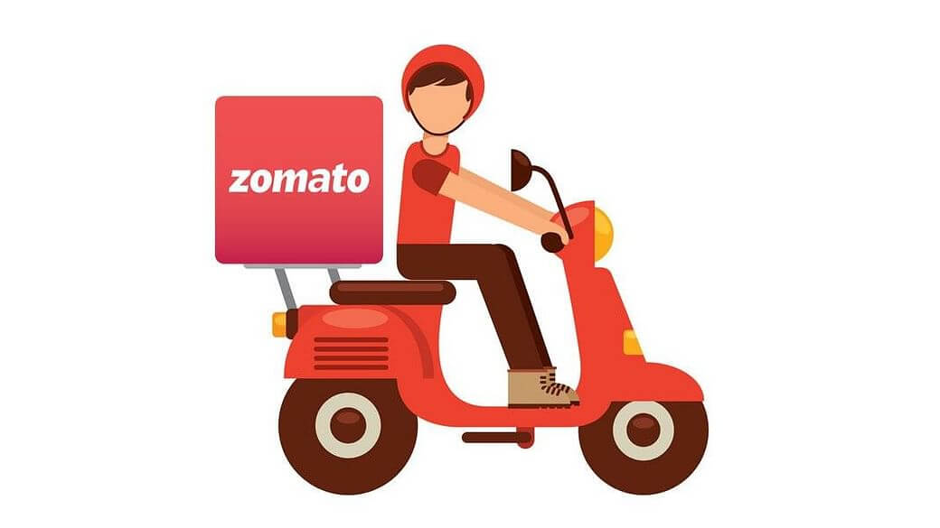

**Product Dissection for Zomato**

### **Company Overview:**

Zomato is a leading global restaurant discovery and food delivery platform that connects millions of customers with restaurants and delivery partners. Founded in 2008 by Deepinder Goyal and Pankaj Chaddah in India, Zomato has grown from a simple restaurant menu aggregation website into a comprehensive food-tech ecosystem operating in multiple countries.

The platform enables users to:

* **Discover Restaurants** through location-based search, cuisine filters, ratings, and reviews.
* **Browse Menus and Prices** in real-time, ensuring transparency and informed decision-making.
* **Read and Write Reviews** to share authentic dining experiences.
* **Place Online Orders** for food delivery with real-time tracking.
* **Reserve Tables** for dine-in experiences at partner restaurants.

For restaurants, Zomato provides tools to manage their menus, orders, and delivery logistics, as well as access to a large customer base. For delivery partners, it offers flexible earning opportunities and route optimization.

### **Product Dissection and Real-World Problems Solved by Zomato:**

Zomato addresses multiple real-world challenges in dining and food delivery through a single, integrated platform. Its **restaurant search and discovery** feature helps users quickly find suitable dining options by applying filters such as cuisine, location, ratings, and offers, solving the common problem of decision-making in unfamiliar areas.

With **menu browsing and real-time pricing**, customers no longer need to call or visit restaurants for details. Digital menus with updated prices and availability bring transparency and convenience to the selection process.

**User reviews and ratings** provide trustworthy insights by collecting verified feedback from diners, helping customers make informed choices and ensuring restaurants are held to quality standards.

The **online ordering and food delivery** system eliminates the need to travel for meals, offering real-time tracking and timely delivery through an optimized network of delivery partners.

For dine-in customers, **table reservations** remove the hassle of long waits at popular spots, while **personalized recommendations** use AI to suggest options based on past orders and preferences, reducing choice overload.

From a business perspective, Zomato’s **restaurant partner tools** enable establishments to manage menus, process orders, track performance, and run promotions, increasing their visibility and efficiency. Integrated **delivery partner management** ensures orders are fulfilled quickly through automated assignment and route optimization.

A strong example is Zomato’s handling of **late-night food access**. Customers can filter for “Open Now” restaurants, view available menu items, and get deliveries even during off-peak hours. This not only meets user needs but also drives extra revenue for restaurants.

By solving these challenges, Zomato has created a comprehensive ecosystem that benefits customers, restaurants, and delivery partners alike, making it one of the most effective food-tech solutions worldwide.

## 

## 

### 

### 

### **Case Study: Real-World Problems and Zomato's Innovative Solutions**

## Case Study 1: Restaurant Discovery & Health-Conscious Choices

## Scenario

## User: Priya, a health-focused professional in Mumbai Priya often eats out, but she wants to avoid oily food and prefers gluten-free and vegan options. She’s short on time, so quick decision-making is essential.

## Challenges

* Overwhelming restaurant choices in large cities.
* Finding restaurants that offer healthy and dietary-specific options.
* Avoiding restaurants with poor hygiene or ratings.

## Solution via Zomato Features & Schema

* Advanced Search & Filters: Priya uses filters for “vegan”, “gluten-free”, and “healthy” cuisine. Zomato’s schema supports this by tagging MenuItems and Restaurants with relevant dietary categories and health attributes.
* Ratings & Reviews: She reviews hygiene scores and dietary suitability via Reviews, which are structured to link real user feedback to Restaurants.
* Personalization: Priya’s profile (Preferences attribute in Users table) improves future recommendations.
* Location Awareness: The Address field for Restaurants and Users ensures results are nearby.

Schema Touchpoints:

* MenuItems.Category, Restaurant.Cuisine, Review.Rating, Users.Preferences

## Case Study 2: Seamless Group Ordering and Payment Splitting

## Scenario

Users: A group of friends in Bengaluru  
They plan a movie night with home delivery, each wanting different dishes from the same restaurant, with a plan to split bills at checkout.

## Challenges

* Complex orders with multiple people and items.
* Splitting payments fairly and securely.
* Tracking multiple order statuses.

## Solution via Zomato Features & Schema

* Order Aggregation: Users add items to a shared cart, enabled by the relationship between Users, Orders, and OrderItems.
* Flexible Payments: Payment integration allows splitting bills. The Payments table tracks PaymentMethod and PaymentStatus separately for each contributor.
* Live Tracking: Each friend receives notifications via attributes tied to Order and Delivery status.

Schema Touchpoints:

* Orders (one order, multiple OrderItems),
* Payments (possibly multiple linked to same Order),
* Delivery.Status

## Case Study 3: Timely Food Delivery During Peak Hours

## Scenario

User: Amit, a night-shift worker in Delhi  
Amit relies on prompt food delivery during late hours, often facing delays due to high demand or traffic.

## Challenges

* Late-night availability.
* Ensuring fast delivery even with heavy traffic.
* Monitoring delivery partners for reliability.

## Solution via Zomato Features & Schema

* Real-Time Status: The Delivery and DeliveryPersons tables enable Zomato to assign orders quickly and track delivery progress with StartTime, EndTime, and Status.
* Partner Ratings & Tracking: Frequent delays by specific delivery partners can be tracked, and poor performers excluded.
* Dynamic Re-routing: Zomato uses vehicle and delivery data to optimize routes, updating Amit with ETA changes.

Schema Touchpoints:

* Delivery.StartTime, Delivery.EndTime, Delivery.Status,
* DeliveryPerson.Name, VehicleID

## Case Study 4: Coupon Redemption & Loyalty Management

## Scenario

User: Rina, a frequent user  
Rina likes to use coupons for discounts and accumulates loyalty points for free meals.

## Challenges

* Managing multiple, expiring coupons.
* Applying right offers for each order.
* Tracking loyalty points and history.

## Solution via Zomato Features & Schema

* Coupon Tracking: Coupons table stores all codes, expiry dates, types; UserCoupons logs redemption history.
* Automated Suggestions: At checkout, Zomato suggests valid offers, reading from UserCoupons and Coupons, checking expiry and user eligibility.
* Analytics for Loyalty: User’s coupon usage is analyzed to give better future offers.

Schema Touchpoints:

* Coupons.Code, Coupons.ExpiryDate, UserCoupons.UsedOn

# Zomato Schema Description

The Zomato database schema is designed to efficiently manage a wide range of functionalities including user management, restaurant listings, menu items, orders, payments, deliveries, reviews, and promotional offers. The schema captures the core entities, their attributes, and relationships, enabling smooth data flow and strong business logic support.

## Key Entities and Their Descriptions

## 1. Users

* Represents customers who browse restaurants, place orders, and provide feedback.
* Key attributes:
  + UserID (Primary Key): Unique identifier for each user.
  + Name: Full name of the user.
  + Email: Unique email address for login and communication.
  + PasswordHash: Secure password storage.
  + Address: Default delivery location.
  + Preferences: Custom preferences for cuisine, dietary restrictions, etc.

## 2. Restaurants

* Contains information about restaurants listed on Zomato.
* Key attributes:
  + RestaurantID (Primary Key): Unique identifier for each restaurant.
  + Name: Restaurant name.
  + Address: Location details.
  + Cuisine: Type of cuisine(s) offered.
  + AvgRating: Average user rating.
  + OperatingHours: Restaurant business hours.

## 3. MenuItems

* Items offered by each restaurant.
* Key attributes:
  + MenuID (Primary Key): Unique identifier for each menu item.
  + RestaurantID (Foreign Key): Links item to a specific restaurant.
  + Name: Name of the dish or item.
  + Description: Details about the dish.
  + Price: Cost per unit.
  + Category: E.g., appetizer, main course, desserts.

## 4. Orders

* Records placed orders.
* Key attributes:
  + OrderID (Primary Key): Unique order identifier.
  + UserID (Foreign Key): User who placed the order.
  + RestaurantID (Foreign Key): Restaurant fulfilling the order.
  + OrderTime: Timestamp of order placement.
  + TotalAmount: Total cost.
  + Status: Order status (Pending, Confirmed, Delivered, Cancelled).

## 5. OrderItems

* Details of items within each order.
* Key attributes:
  + OrderItemID (Primary Key): Unique identifier per item ordered.
  + OrderID (Foreign Key): Links to the corresponding order.
  + MenuID (Foreign Key): Menu item ordered.
  + Quantity: Number of pieces ordered.

## 6. Payments

* Payment details for orders.
* Key attributes:
  + PaymentID (Primary Key): Unique payment record.
  + OrderID (Foreign Key): Order associated with the payment.
  + Amount: Paid amount.
  + PaymentMethod: Mode of payment (Credit Card, UPI, Wallet, COD).
  + PaymentStatus: Status of payment (Completed, Failed, Pending).
  + PaymentTime: Timestamp of payment.

## 7. DeliveryPersons

* Delivery partners responsible for order fulfillment.
* Key attributes:
  + DeliveryPersonID (Primary Key): Unique delivery personnel identifier.
  + Name: Delivery agent name.
  + Phone: Contact number.
  + VehicleID: Identifier for delivery vehicle.

## 8. Delivery

* Tracks delivery details per order.
* Key attributes:
  + DeliveryID (Primary Key): Unique delivery record.
  + OrderID (Foreign Key): Order being delivered.
  + DeliveryPersonID (Foreign Key): Assigned delivery partner.
  + StartTime: Delivery start time.
  + EndTime: Delivery completion time.
  + Status: Delivery status (In Transit, Delivered).

## 9. Reviews

* User reviews and ratings for restaurants.
* Key attributes:
  + ReviewID (Primary Key): Unique review identifier.
  + UserID (Foreign Key): User who wrote the review.
  + RestaurantID (Foreign Key): Reviewed restaurant.
  + Rating: Numeric rating score.
  + Comment: Text feedback.
  + ReviewDate: Date of the review.

## 10. Coupons

* Coupons and promotional offers.
* Key attributes:
  + CouponID (Primary Key): Unique coupon code identifier.
  + Code: Coupon code string.
  + DiscountType: Type of discount (Percentage, Fixed amount).
  + DiscountValue: Value of the discount.
  + ExpiryDate: Validity end date.

## 11. UserCoupons

* Tracks coupon usage per user.
* Key attributes:
  + UserID (Foreign Key): User who redeemed the coupon.
  + CouponID (Foreign Key): Coupon redeemed.
  + UsedOn: Timestamp of coupon usage.

# Zomato Schema – Relationship Overview

## 1. User → Orders *(One-to-Many)*

* Meaning: One user can place multiple orders, but each order belongs to only one user.
* Tables involved: Users → Orders
* Key Link: Users.UserID → Orders.UserID

## 2. Restaurant → MenuItems *(One-to-Many)*

* Meaning: A restaurant can have many menu items, but each menu item belongs to only one restaurant.
* Tables involved: Restaurants → MenuItems
* Key Link: Restaurants.RestaurantID → MenuItems.RestaurantID

## 3. Order → OrderItems *(One-to-Many)*

* Meaning: Each order can contain multiple individual items, but each order item belongs to just one order.
* Tables involved: Orders → OrderItems
* Key Link: Orders.OrderID → OrderItems.OrderID

## 4. MenuItem → OrderItems *(One-to-Many)*

* Meaning: One menu item can be part of multiple order items (across different orders), but each order item refers to one menu item only.
* Tables involved: MenuItems → OrderItems
* Key Link: MenuItems.MenuID → OrderItems.MenuID

## 5. Order → Payment *(One-to-One)*

* Meaning: Each order has exactly one payment record, and each payment belongs to exactly one order.
* Tables involved: Orders → Payments
* Key Link: Orders.OrderID → Payments.OrderID

## 6. Order → Delivery *(One-to-One)*

* Meaning: Each order can have one delivery record, each delivery corresponds to exactly one order.
* Tables involved: Orders → Delivery
* Key Link: Orders.OrderID → Delivery.OrderID

## 7. DeliveryPerson → Delivery *(One-to-Many)*

* Meaning: A delivery person can be assigned to multiple deliveries, but each delivery record has only one delivery person assigned.
* Tables involved: DeliveryPersons → Delivery
* Key Link: DeliveryPersons.DeliveryPersonID → Delivery.DeliveryPersonID

## 8. User → Review → Restaurant *(Many-to-Many via Review Table)*

* Meaning:
  + A user can write reviews for many restaurants.
  + A restaurant can receive reviews from many users.
* Implementation: Achieved through the Reviews table, which links Users and Restaurants.
* Tables Involved: Users, Reviews, Restaurants
* Key Links:
  + Users.UserID → Reviews.UserID
  + Restaurants.RestaurantID → Reviews.RestaurantID

## 9. User → Coupon → UserCoupons *(Many-to-Many via UserCoupons Table)*

* Meaning:
  + A user may redeem multiple coupons.
  + A coupon may be redeemed by multiple users.
* Implementation: Achieved through the UserCoupons table.
* Tables Involved: Users, UserCoupons, Coupons
* Key Links:
  + Users.UserID → UserCoupons.UserID
  + Coupons.CouponID → UserCoupons.CouponID

**ER Diagram:**

